Analysis of Competitive Advantage in Real Companies



NAME : J ASHOK CHANDRA

DR LANKAPALLI BULLAYYA COLLEGE

BBA FINAL YEAR

16/03/2024

**TABLE OF CONTENTS**

# 

# Introduction.

# Objective of the Analysis.

# Company Overview.

# Competitive advantage.

# SWOT analysis of the company.

# Analysis of financial performance.

# Comparison of Market position in industry.

## Future viability of strategies and Opportunities .

# Conclusion & bibliography.

# 

# 

**Introduction**

# **Objective of Analysis:**

1. To analyze the competitive advantages of two real companies operating in different industries.
   1. Technology sector
   2. Consumer goods sector
2. Identify, evaluate the competitive strengths that contribute to each company's success .
3. To evaluate the financial performance of both companies.
4. To ascertain the long term viability of the company’s competitive advantage.

# **COMPANY OVERVIEW:**

* This section will provide a summary about both the companies and key insights

## 

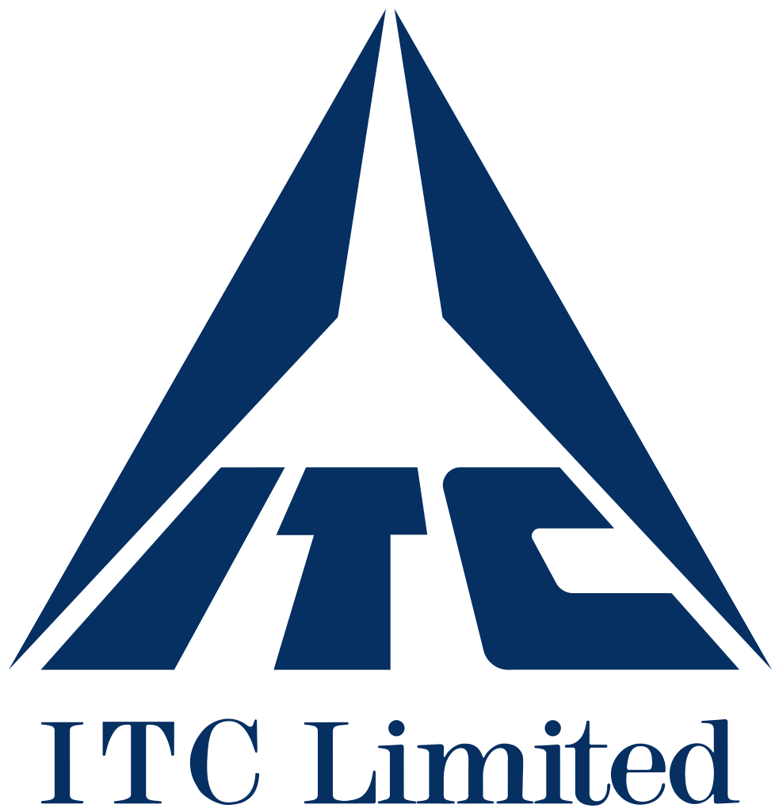

# 

# **Meta Platforms, Incs.**

**Meta Platforms, Inc.**,doing business as **Meta**,and formerly named **Facebook, Inc.**, and **TheFacebook, Inc.**,is an American multinational technology conglomerate based in Menlo Park, California. The company owns and operates Facebook, Instagram, Threads, and WhatsApp, among other products and services.Meta ranks among the largest American information technology companies, alongside other Big Five corporations Alphabet (Google), Amazon, Apple, and Microsoft. The company was ranked #31 on the Forbes Global 2000 ranking in 2023.

Meta has also acquired Oculus (which it has integrated into Reality Labs), Mapillary, CTRL-Labs, and a 9.99% stake in Jio Platforms; the company additionally endeavored into non-VR hardware, such as the discontinued Meta Portal smart displays line and presently partners with Luxottica through the Ray-Ban Stories series of smart glasses. Despite endeavors into hardware, the company relies on advertising for a vast majority of its revenue, amounting to 97.8 percent in 2023.

Parent company Facebook, Inc. rebranded as Meta Platforms, Inc. on October 28, 2021, to "reflect its focus on building the metaverse",an integrated environment linking the company's products and services.

# **ITC Limited**

**ITC Limited** is an Indian conglomerate company headquartered in Kolkata. ITC has a diversified presence across industries such as FMCG, hotels, software, packaging, paperboards, specialty papers and agribusiness. The company has 13 businesses in 5 segments. It exports its products in 90 countries. Its products are available in 6 million retail outlets.

On 17 April 2023, its market cap crossed the milestone of ₹500,000 crore (US$63 billion) for the first time in company's history, followed by crossing the ₹600,000 crore (US$75 billion) mark on 20 July 2023 and becoming the biggest FMCG Company in India passing the Hindustan Unilever's market cap the very next day. It employs 36,500 people at more than 60 locations across India.

Competitive Advantage

* This section illustrates the competitive advantage i.e. the strengths of both companies META & ITC on basis of brand image, market mix and distribution channels.

# **Meta Platforms, Inc. [** formerly **FACEBOOK]**

## **Meta** has a **STRONG BRAND** With **net worth** of $1.31 trillion as of March 8 2024.& **LARGE USER BASE** of **3.98 billion** people using at least one of company’s core product **(whatsapp, facebook, instagram, messenger)**

## **Diversified Portfolio** is **Meta’s** major Strength asMeta does not put all of its eggs in one basket. Instead spread its investments across various areas i.e APPS.

## 

## **3. Visionary Leadership** of **MARK ZUCKERBERG** is **Meta’s Cornerstone**. The fruits of Zuckerberg’s strong visionary leadership include company culture, stability, increased profitability, innovation, and sustainability with minimum internal wrangles within its ranks and management, unlike most other companies.

## **4. Meta( facebook)** is a Strong **ADVERTISING Business.**

Therefore, it generates majority of its Annual revenue from

Advertisements. In 2023 the **advertising revenue** was **$131.95**

**Billion.**

# **ITC Limited [** formerly **INDIAN TOBACCO COMPANY LIMITED]**

## **ITC Ltd.** has diversified **PORTFOLIO** in **FMCG, hotels, packaging, paperboards & speciality papers** and **Agri-business**. Approximately 69% of revenue comes from the FMCG segment.

## **ITC LTD.** is INDIA’S **Largest Cigarette Producer** with a **market share** over **75%** in INDIA & is the absolute MARKET LEADER.

## **ITC Ltd.** has the **LARGEST MARKET CAPITALIZATION** of 4.3 trillion. And its stocks are considered number 1 in market capitalization category compared to similar companies.

## **ITC Ltd.** has made several astute **acquisitions** to help the company **expand** into new business areas :

### **Tecnico Agri Science**

### **Sunrise Foods**

### **Bluepin Technologies**

## **ITC Ltd.** has a strong brand recognition as it **RANKED #1** among the **top-ten FMCG brands** in **INDIA** with a market share of 14%.

## 

## 

## 

## **ITC Ltd.** has **200 manufacturing facilities** in India & a distribution network spanning **7 million Retail outlets** across various trade channels. ITC also has **113 HOTEL Properties**.

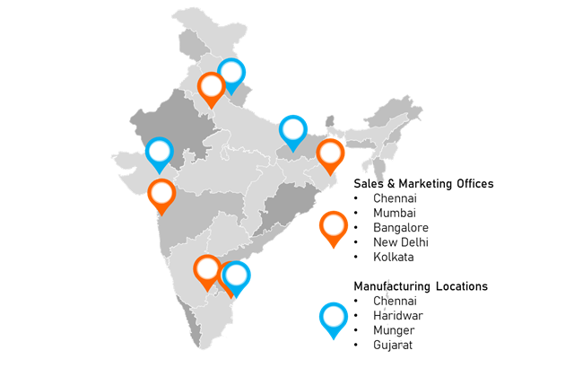

Analysis of Financial Performance

For the analysis of financial performance and competence of both **META PLATFORMS, INC. & ITC LIMITED** , the following metrics/ KPIs are use which are as follows :

1. ANNUAL REVENUE GROWTH .
2. MARKET CAPITALIZATION.
3. YEARLY GROSS PROFIT.
4. RETURN ON INVESTMENT.

# **Meta Platforms, Inc.**

#1 ANNUAL REVENUE GROWTH:

Meta Platforms annual revenue history and growth rate from 2010 to 2023. Revenue can be defined as the amount of money a company receives from its customers in exchange for the sales of goods or services. Revenue is the top line item on an income statement from which all costs and expenses are subtracted to arrive at net income.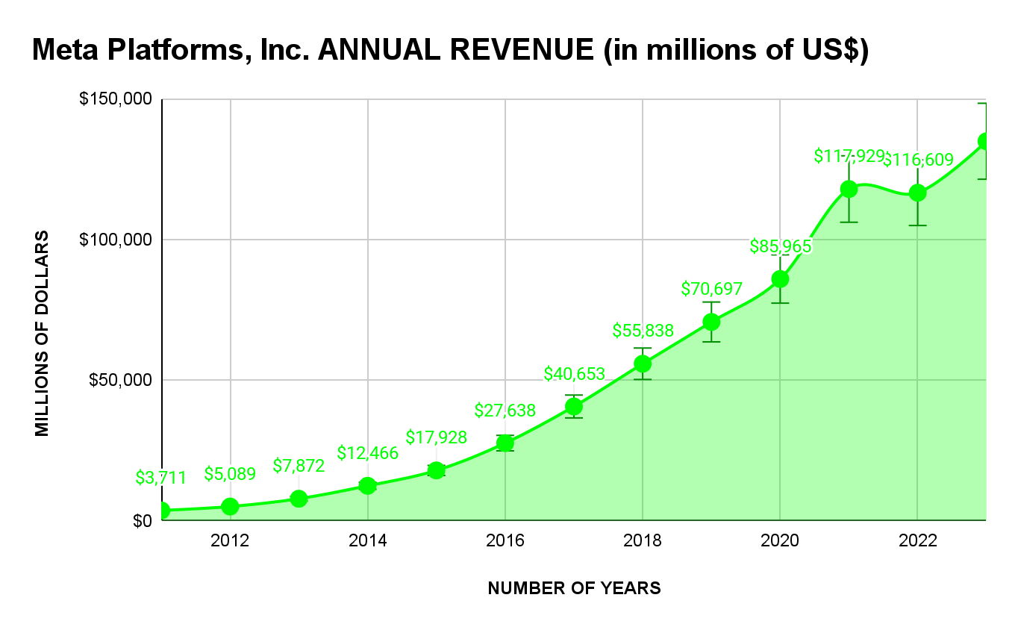

* Meta Platforms annual revenue for 2023 was **$134.902B**, a **15.69% increase** from 2022.
* Meta Platforms annual revenue for 2022 was **$116.609B**, a **1.12% decline** from 2021.
* Meta Platforms annual revenue for 2021 was **$117.929B**, a **37.18% increase** from 2020.

#2 MARKET CAPITALIZATION :

Meta Platforms shares outstanding history from 2010 to 2023. Shares outstanding can be defined as the number of shares held by shareholders (including insiders) assuming conversion of all convertible debt, securities, warrants and options. This metric excludes the company's treasury shares.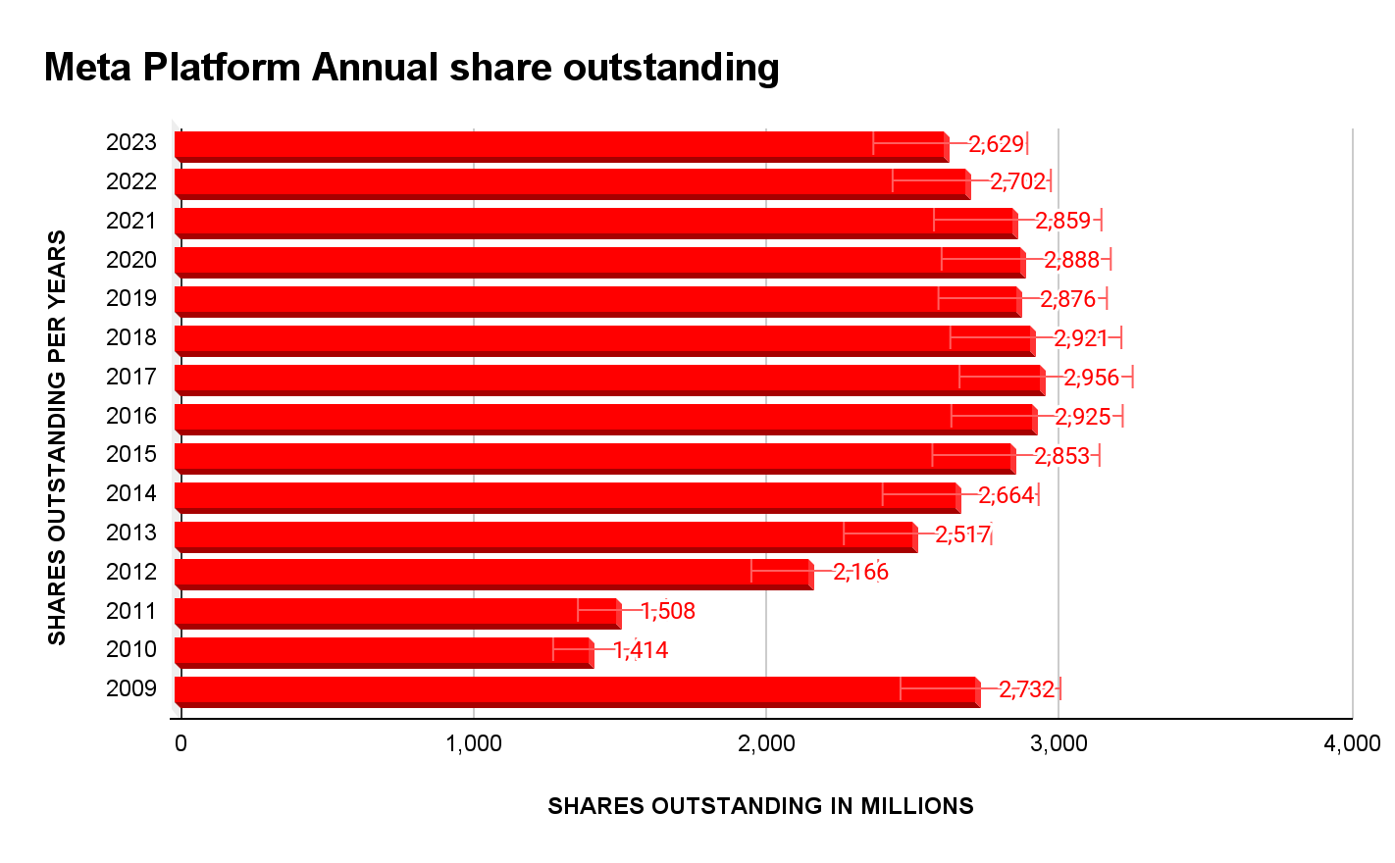

* Meta Platforms 2023 shares outstanding were **2.629B**, a **2.7% decline** from 2022.
* Meta Platforms 2022 shares outstanding were **2.702B**, a **5.49% decline** from 2021.
* Meta Platforms 2021 shares outstanding were **2.859B**, a **1% decline** from 2020.

#3 YEARLY GROSS PROFIT :

Meta Platforms annual gross profit history and growth rate from 2010 to 2023. Gross profit can be defined as the profit a company makes after deducting the variable costs directly associated with making and selling its products or providing its services.

* Meta Platforms annual gross profit for 2023 was **$108.943B**, a **19.25% increase** from 2022.
* Meta Platforms annual gross profit for 2022 was **$91.36B**, a **4.11% decline** from 2021.
* Meta Platforms annual gross profit for 2021 was **$95.28B**, a **37.54% increase** from 2020.

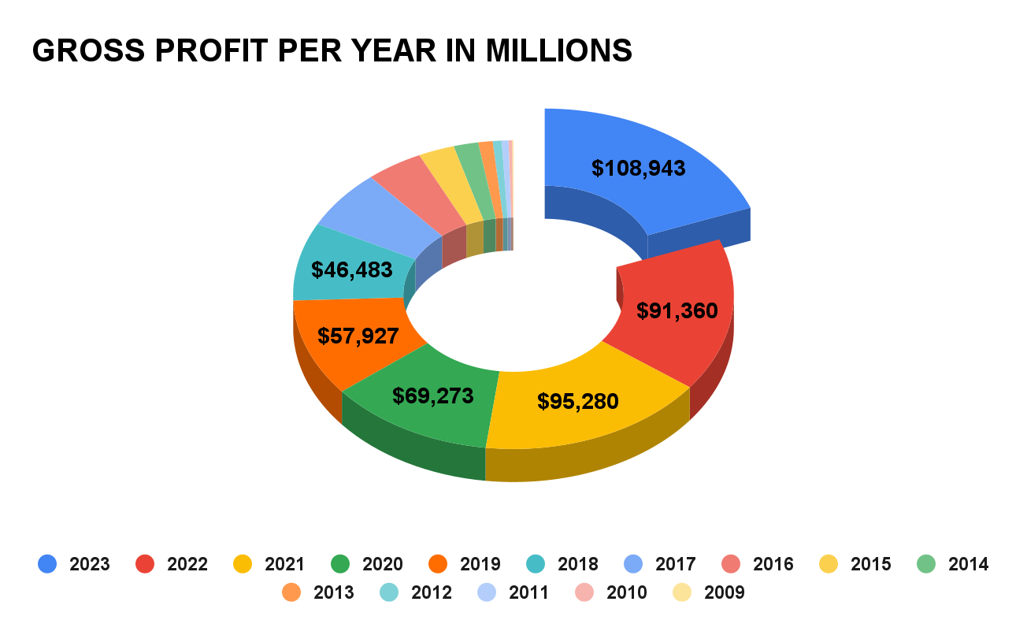

#4 RETURN ON INVESTMENT :

**Current and historical return on investment (ROI) values for Meta Platforms (META) over the PREVIOUS YEARS.**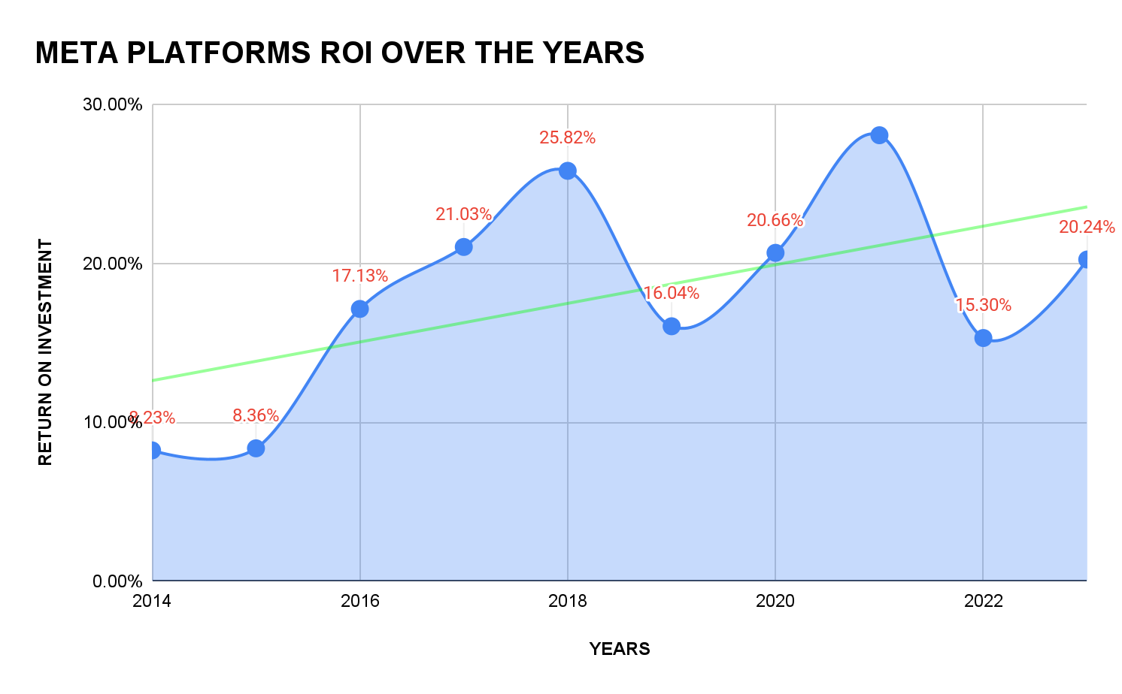

# **ITC Limited**

#1 ANNUAL REVENUE GROWTH :

ITC Limited annual revenue history and growth rate from 2012 to 2023. Revenue can be defined as the amount of money a company receives from its customers in exchange for the sales of goods or services. Revenue is the top line item on an income statement from which all costs and expenses are subtracted to arrive at net income.

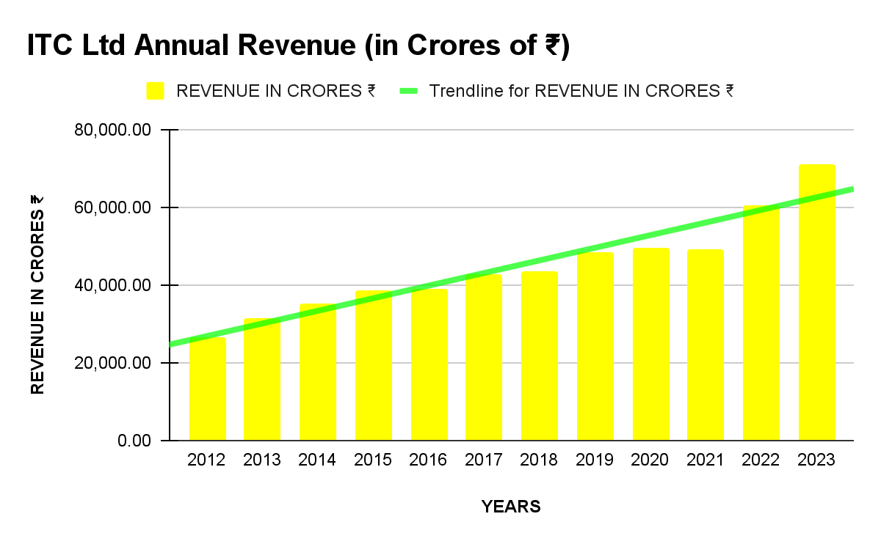

* ITC limited annual revenue for 2023 was 70,593 Crores INR, an increase of **16.94%** from 2022.
* ITC limited annual revenue for 2022 was 60,645 Crores INR, an increase of **23.12%** from 2021.
* ITC limited annual revenue for 2021 was 49,257 Crores INR, an increase of **0.26%** from 2020.

#2 YEARLY GROSS PROFIT :

ITC Limited annual gross profit history and growth rate from 2012 to 2023. Gross profit can be defined as the profit a company makes after deducting the variable costs directly associated with making and selling its products or providing its services.

* ITC limited annual gross profit for 2023 was 25,704 Crores INR, with an **OPERATING PROFIT MARGIN %**  of **36%.**
* ITC limited annual gross profit for 2022 was 20,623 Crores INR, with an **OPERATING PROFIT MARGIN %** of **34%.**
* ITC limited annual gross profit for 2021 was 17,065 Crores INR, with an **OPERATING PROFIT MARGIN%** of **35%.**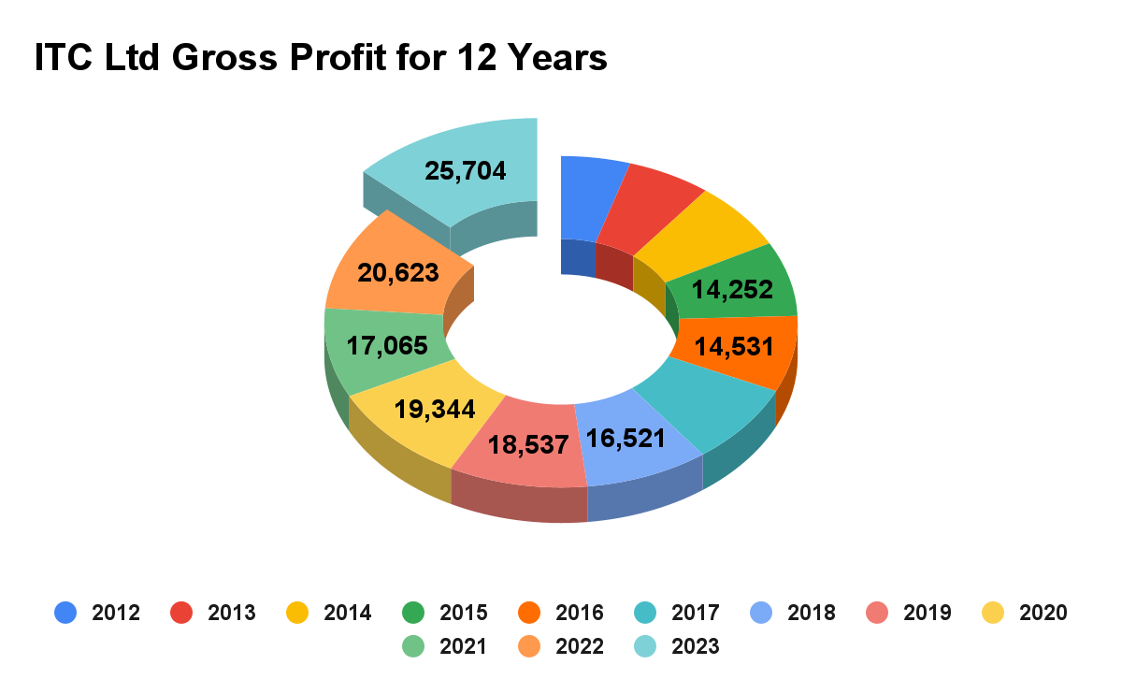

#3 RETURN ON INVESTMENT :

**Current and historical return on investment (ROI) values for ITC Limited (META) over the PREVIOUS YEARS.**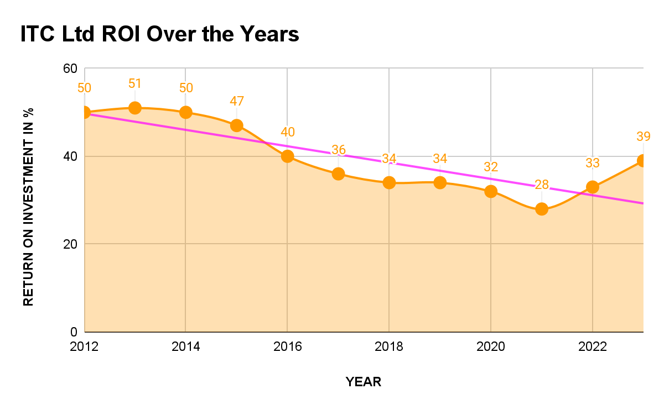

Industry Market Position

# **Meta Platforms, Inc.**

## **Most Used Social Media Platforms in India 2024**

In India, Instagram is the most used social media platform in 2024 with 74.70% of the internet users enrolled. The number of active Instagram users in India comes to 516.92 million. A big percentage of Instagram’s users are young people, especially teenagers. Meta, the parent company which paid $1 billion to buy Instagram. It has grown into a source of income for creators and a great sales channel for businesses. Therefore, businesses looking to enhance their visibility on the platform try to buy Instagram followers from Views4You which can be a strategy for new or growing accounts seeking to establish a significant presence.

71.20% of the internet users in India have profiles on Facebook and that makes it the second most popular platform with 492.70 million active internet users. Among the commercial entities, the political class as well as the masses in India, Facebook is most favored and will remain a dominant force for many years to come. Facebook has been used by many top brands to engage with their fans.

A few other social media platforms that are popular in India are X (formerly Twitter) (42.90% penetration), LinkedIn (35.7% penetration), Moj (29.50% penetration), a short video community, made locally and specially followed by Pinterest (29% penetration). There are few new entrants like Moj Lite + (26.20% penetration), another short video app. Next on the list are TikTok (23.00% penetration), Skype (20.30% penetration) and Helo (19.40% penetration).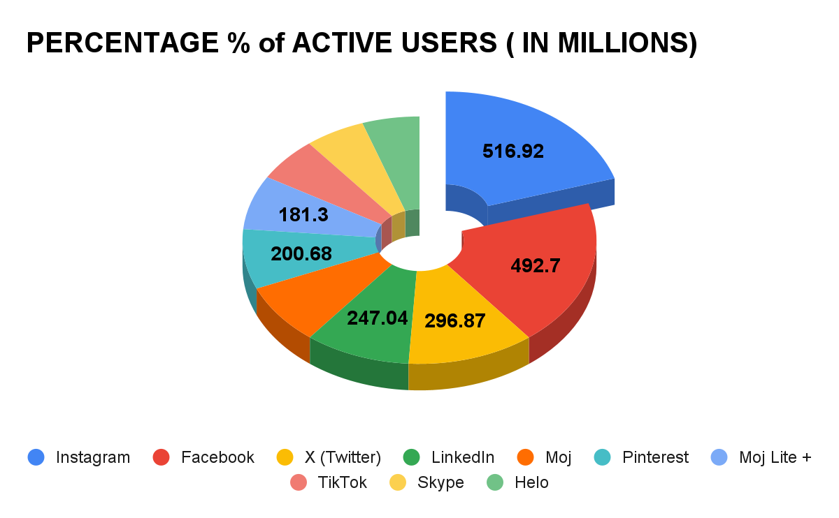

# **ITC Limited**

**ITC limited’s RANKING in the top FMCG companies in India as of February 26, 2024.**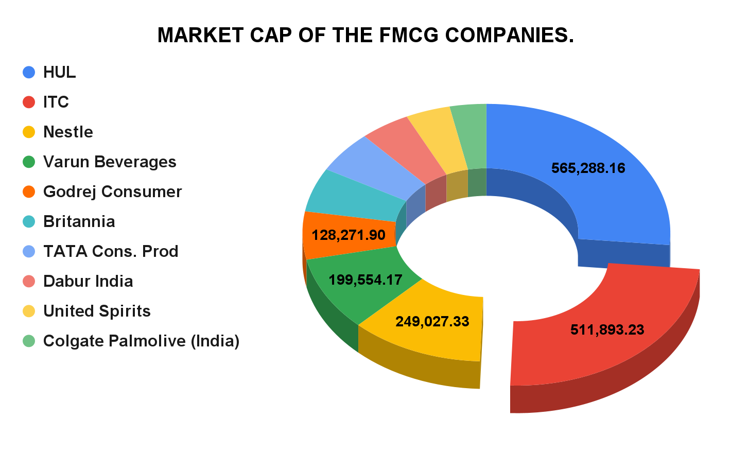

**ITC LIMITED**

* **Founded on: August 24, 1910**
* **CMD: Sanjiv Puri**

ITC has retained its position as one of the top FMCG companies in India due to its diversified business portfolio. You can find ITC everywhere, from consumer goods to hotels, agri-business, paperboards, packaging and more, making it a conglomerate with a significant presence in India. This diversification provides stability and reduces dependency on a single industry, contributing to overall business resilience.

Future Viability of Strategies and Opportunities

# **Meta Platforms, Inc.**

The metaverse is an immersive experience in which the lines are blurred between the physical and virtual worlds. It’s a different internet experience altogether. Users will no longer look at a screen to interact with each other. They will be in those experiences thanks to the power of virtual reality technology.

**Meta** is planning to change digital communication in three key areas:

1. **Education**: Meta has invested $150 million in building resources that will change the way people learn. The company is building a complete VR education space that will include museum visits, access to libraries, and state-of-the-art research tools for STEM education.
2. **Work:** Meta’s Horizon Workroom will help colleagues collaborate in virtual spaces. Each person will be represented by an avatar to mimic the authentic experience of working in an office.
3. **Leisure:** Meta is also changing the way people socialize. The company is building a VR ecosystem that will offer multiple immersive experiences. Users can choose to join groups and communities that share similar interests such as fitness groups and sports teams.

Here is how Meta will help users access the metaverse:

* **Virtual Reality Headsets:** Meta’s Quest headsets allow users to experience three-dimensional worlds. The headset comes with touch controls that can be strapped to each hand. The controls act like extensions of your own hands in the virtual world.
* **Augmented Reality**: Meta is building a Spark AR platform that will help users add virtual effects to their photos and videos. The Spark Studio contains hundreds of user-friendly templates so that anyone can experiment with virtual animation without the need for any coding experience.
* **Smart Glasses**: Meta is developing smart Ray-Bans that can be used to capture photos and videos, listen to music, and receive phone calls. Meta is also developing a Facebook View App so that users can easily share their Ray-Ban content with others.

# FUTURE OPPORTUNITIES FOR **META**

**METAVERSE** has several opportunities that it can leverage to continue its growth and success. Some of the main opportunities for Facebook are:

1. **E-commerce**: Facebook has already launched Facebook Shops, which allows businesses to sell their products directly on the platform. Facebook can further expand into e-commerce, a rapidly growing market, by integrating more e-commerce features, such as payments and shipping.
2. **Virtual Reality (VR)**: Facebook’s acquisition of Oculus VR allows the company to develop and monetize VR experiences and content. The VR market is expected to grow significantly in the coming years, which presents a significant opportunity for Facebook.
3. **Video content:** Facebook’s video content is already popular among users and advertisers. The company can expand this market by creating original content and attracting more creators to the platform.
4. **Emerging markets**: Facebook can continue to grow its user base by expanding into emerging markets, such as India and Africa. These markets have large populations and high growth potential.
5. **Augmented Reality (AR)**: Facebook is investing in AR technology, which can provide new opportunities for advertising, gaming, and social interactions. As AR technology advances, Facebook can leverage its large user base to create engaging AR experiences.

These opportunities can help Facebook continue its growth and remain competitive in the ever-changing digital landscape.

# **ITC Limited**

ITC Next is a strategic initiative undertaken by ITC Limited, a diversified conglomerate in india. Under the visionary leadership of Chairman Sanjiv Puri, the ITC Next strategy aims to reimagine businesses for a redefined future. Here are some key aspects of this strategy:

1. **Agility and Resilience:** ITC focuses on agility and resilience, adapting swiftly to dynamic operating environments.
2. **Innovation and Digital Acceleration:** The company invests in innovation and accelerates digital transformation to stay ahead.
3. **Cost Optimization:** ITC optimizes costs while ensuring efficiency across its operations.
4. **Customer-Centric Approach:** The strategy emphasizes customer needs and preferences.
5. **New Growth Avenues:** ITC explores new avenues for growth.
6. **Flexible Supply Chain:** the company ensures a flexible supply chain to meet market demands.

The FMCG ( Fast-Moving Consumer Goods) segment, in particular, has witnessed robust performance under the ITC Next strategy. By fortifying existing brands, exploring brand extensions, and nurturing new platforms, ITC aims to remain Future-oriented and Consumer-Centric.

# FUTURE OPPORTUNITIES FOR **ITC LIMITED**

The following are opportunities for ITC’s growth and development:

**#1 GROWING FMCG MARKET:**

ITC Ltd has the potential to capitalize on the expanding Fast-Moving Consumer Goods (FMCG) market. The growing FMCG market offers ITC Ltd an opportunity to diversify its revenue streams beyond its core businesses. While the company has a strong presence in sectors such as tobacco, hotels, paperboard, and agribusiness, the FMCG market provides a new avenue for expansion. The FMCG market thrives on innovation and new product development, providing ITC Ltd with an opportunity to showcase its research and development capabilities. The company can leverage its expertise in product development, packaging, and formulation to introduce innovative and value-added FMCG products. In conclusion, ITC Ltd’s diverse portfolio of businesses can create synergies and cross-promotional opportunities within the FMCG market.

**#2 EXPANSION INTO EMERGING MARKETS:**

By expanding its presence into emerging markets, ITC Ltd can target a new set of consumers who are eager to explore and adopt new products and brands. By strategically entering and expanding in emerging markets, ITC Ltd can position itself for long-term growth, enhanced profitability, and sustainable business performance.

**#3 FOCUS ON HEALTH AND WELLNESS:**

By leveraging its existing resources, research and development capabilities, and consumer insights, ITC Ltd can introduce a range of health-focused products that cater to the evolving needs of health-conscious consumers. By aligning its business strategy with the health and wellness trend, ITC Ltd can capture market share, enhance consumer loyalty, and drive long-term growth.

**#4 ACQUISITIONS AND PARTNERSHIPS:**

By acquiring businesses in related or complementary sectors, ITC Ltd can enter new markets, gain access to new customer segments, and broaden its product offerings. These strategic moves allow the company to reduce its reliance on specific sectors, mitigate risks associated with market fluctuations, and create a more balanced revenue stream.

**#5 ADOPTION OF E-COMMERCE:**

By establishing a strong online presence, the company can tap into a larger customer base, including those who prefer the convenience of shopping online. E-commerce enables ITC Ltd to reach customers in remote areas, international markets, and underserved regions, thereby increasing its market penetration and potential revenue streams.

**CONCLUSION**

* From the above analysis, it is clear that both meta and ITC limited are booming and dominating their respective industry sectors.
* Meta Platforms, inc. has a very dominant position in the market in terms of market capitalization of itd stocks and with the highest active user base. Financially Meta has performed very well over the decade from 2011-2023. Despite going through major organization altering events like the recent acquisition of
  + Whatsapp, Instagram and oculus
  + Investing in virtual reality tech
  + Changing its name from Facebook to Meta.
* ITC limited with its years of experience and strategies has dominated the FMCG sector, hotels industry along with being the market leader in cigarette manufacturing and distribution. ITC Ltd has proved to be a better company in comparison to its rival HUL (Hindustan Unilever Ltd) by becoming number one in the FMCG sector with the highest Market share and Market CAP. With a positive financial track record the ITC Ltd continues to tighten its grip on existing markets and is also entering into new markets by diversifying its brand portfolio by acquiring existing brands, rebranding and investing heavily in R&D of new innovative products thanks to the profits it's generated for the past 2 decades.

# **References (bibliography):**

* For the content and financial data the following references are used :-

1. <https://www.forbesindia.com/article/explainers/top-10-fmcg-companies-in-india-by-market-cap/89367/1>
2. <https://www.screener.in/company/ITC/consolidated/#profit-loss>
3. <https://m.economictimes.com/industry/cons-products/fmcg/the-classic-pivot-charting-itcs-fmcg-growth-story/amp_articleshow/104391448.cms>
4. <https://bstrategyhub.com/swot-analysis-of-itc/>
5. <https://www.macrotrends.net/stocks/charts/META/meta-platforms/total-assets>
6. <https://bstrategyhub.com/facebook-swot-analysis/#1_Generate_Diversified_Revenue_Sources>
7. <https://thestrategystory.com/blog/facebook-meta-swot-analysis/#google_vignette>
8. <https://csimarket.com/stocks/compet_glance.php?code=META#:~:text=META%20Sales%20vs.&text=Comparing%20the%20current%20results%20to,achieved%20in%20the%20same%20quarter.>